**Pimpri Chinchwad College of Engineering**

**Department of MCA**

**Web Technology Lab**

**Assignment No. 02 : Assignments based on Border, Font, Text, Color, Table, List**

**Date of Submission : 3rd June 2022**

Q.1) Design the following layout using HTML and CSS

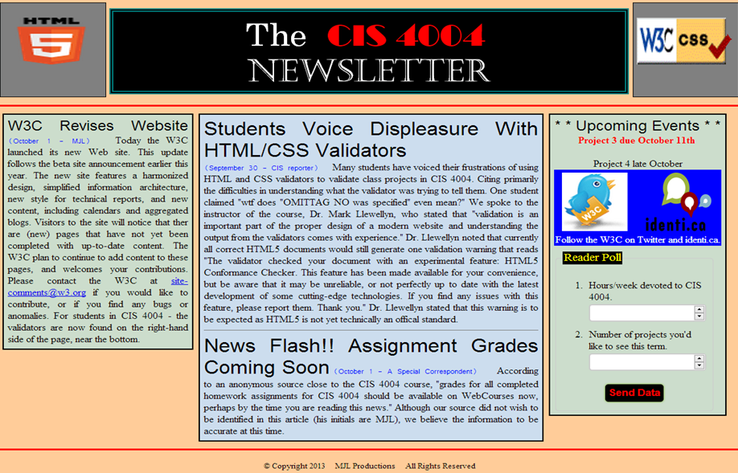

Q.2) Design the following layout using HTML and CSS

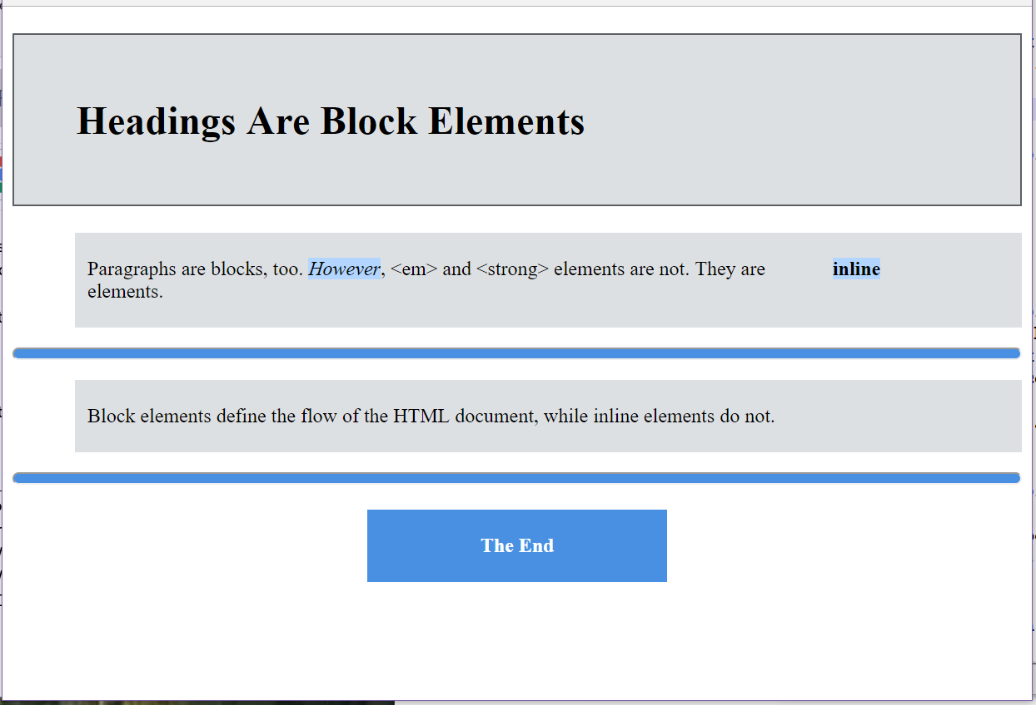

Q.3) Design the following layout using HTML and CSS

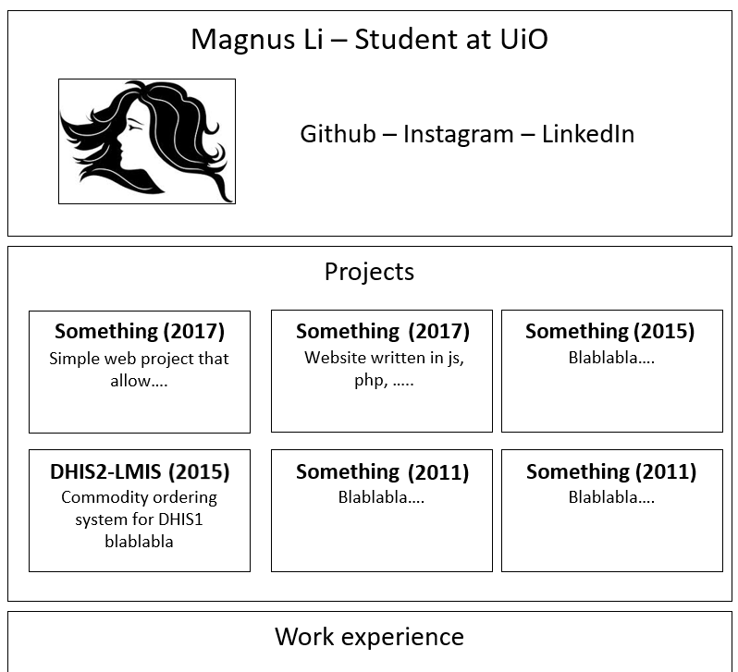

Q.4 ) Demonstrate list, position, and display properties using CSS.